For any of the items below go to [www.facebook.com/arcofsanjoaquin](http://www.facebook.com/arcofsanjoaquin)

and click on **Join My List** or Contact Us at <http://arc-sjorg.presencehost.net/who-we-are/contact.html>.

### Board Interest

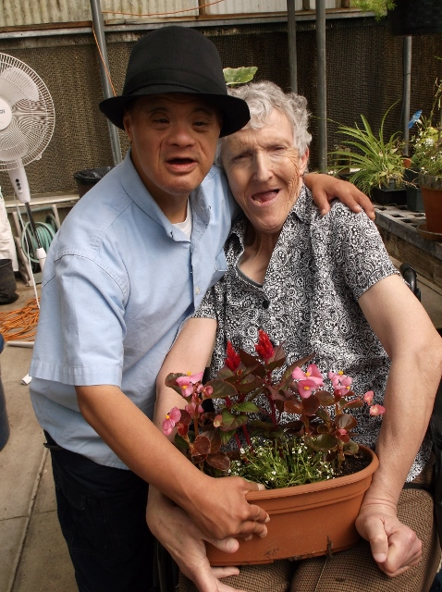

**2017-2018 Board Members & Officers**

Judy Quintana, President – VP Latino Times, Sibling

Maurine Harkness, Special Education Instructor, Retired – Treasurer

Kevin Friscia, Secretary - General Manager, ZM Technologies

Sue Daugherty – Member, Intern Specialist, University of the Pacific, Parent

## Becoming a Board Member

Vision & Strategic Leadership

____Contact me about serving on the Board

____Schedule me for a programs tour

____Send me more information about The Arc

____Add me to your mailing list

____Contact me about other ways to support The Arc.

# The San Joaquin

# The Arc San Joaquin

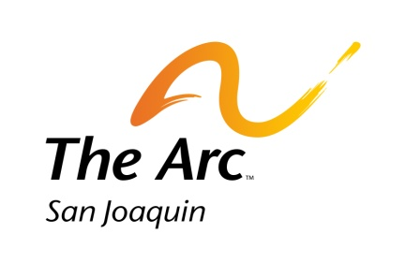

Tel: 209.955.1625

41 W. Yokuts Avenue

Stockton, CA 95207

Phone: 209.955.1625

www.thearcsj.org



ure or graphic.



#### Board of Directors Main Responsibilities

* Promote the mission of Arc San Joaquin and enhance the public image of The Arc
* Setting direction and making policy and strategic decisions
* Overseeing and monitoring organizational performance and ensuring overall accountability
* Attend scheduled Board meetings* and any special meetings.
* Select and evaluate the Executive Director.
* Plan and support fundraising projects.

*9 Board meetings per year. Term of service is 3 years.



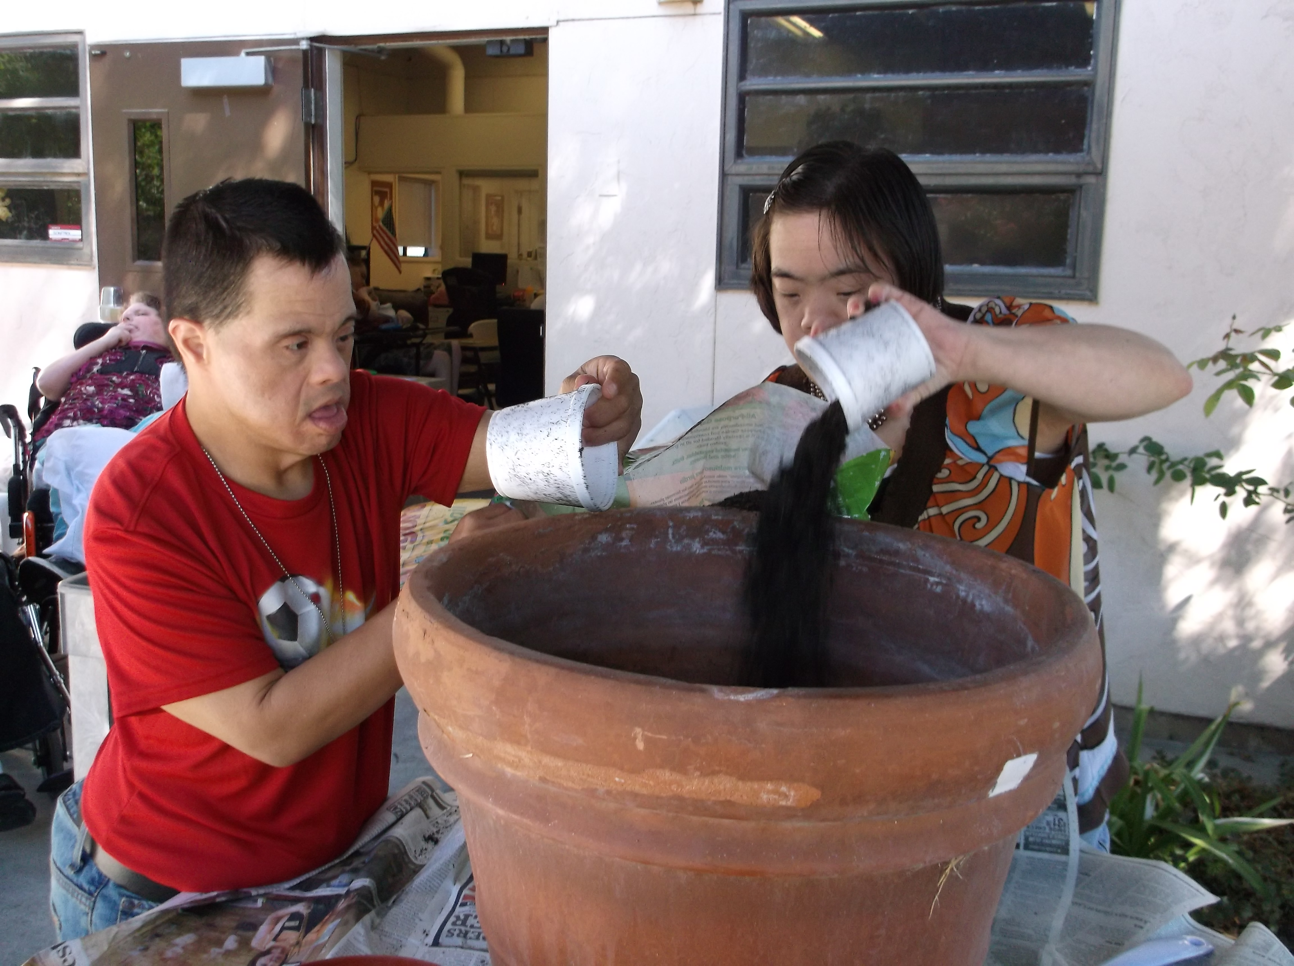

**History**

Arc San Joaquin began in 1954 when a group of concerned parents advocated for services in Stockton for persons with developmental and intellectual disabilities. These initial services have grown into a network of support in the schools system, employment and the community.

**Current Services**

Starting Out and ADC North are adult learning environments where consumers can learn and use living and social skills.

**Vocational Services**

Services are provided for abilities assessment, employment planning, job preparation, work placement and support.

41 W. Yokuts Avenue

Stockton, CA 95207

Phone: 209.955.1625

[www.thearcsj.org](http://www.thearcsj.org)

# The Arc San Joaquin

### The Arc San Joaquin